**DEPT. OF ELECTRICAL & ELECTRONICS ENGINEERING SRM INSTITUTE OF SCIENCE AND TECHNOLOGY, Kattankulathur – 603203.**

|  |
| --- |
| Title of Experiment :7. **Characteristics of semiconductor devices (a) PN junction diode, (b) Zener diode, (c)BJT** |
| Name of the candidate : Debarghya Barik    Register Number : RA2011026010022    Date of Experiment : 04.11.2020 |

|  |  |  |  |
| --- | --- | --- | --- |
| Sl.  No. | Marks Split up | Maximum marks  (50) | Marks obtained |
| 1 | Pre Lab questions | 5 |  |
| 2 | Preparation of observation | 15 |  |
| 3 | Execution of experiment | 15 |  |
| 4 | Calculation / Evaluation of Result | 10 |  |
| 5 | Post Lab questions | 5 |  |
|  | **Total** | **50** |  |

# Staff Signature

# PRE LAB QUESTIONS

1. **What are intrinsic and extrinsic semiconductors?**

**Ans:**

An **intrinsic semiconductor**, also called an undoped semiconductor or i-type semiconductor, is a pure semiconductor without any significant dopant species present.

An **extrinsic semiconductor** is one that has been doped that is impurities are intentionally added for making it conductive.

1. **Give examples for Trivalent and Pentavalent impurity.**

**Ans:**

Examples of **trivalent** impurities are boron, aluminium, and gallium.

Examples of **pentavalent** impurities are antimony, arsenic, phosphorus.

1. **What is the need for Zener diode?**

**Ans:**

**Zener diodes** are used for **voltage regulation**, as **reference elements**, **surge suppressors**, and in **switching applications** and **clipper circuits**. The load voltage equals breakdown voltage VZ of the diode. The diode in series, resistor limits the current through the diode and drops the excess voltage when the diode is conducting. When connected in parallel with a variable voltage source so that it is reverse biased, a Zener diode conducts when the voltage reaches the diode's reverse breakdown voltage.

1. **What is voltage regulation and mention its significance?**

**Ans:**

**Voltage regulation** is a measure of change in the voltage magnitude between the sending and receiving end of a component, such as a transmission or distribution line. Voltage regulation describes the ability of a system to provide near constant voltage over a wide range of load conditions.

**Significance:** Change in load causes changes in current and hence the voltage drop in the circuit as well. It is necessary to maintain the supply voltage of the equipment because the supply voltage directly affects the performance of the equipment. Hence, the voltage regulation is significant.

# 5. Give the different types of semiconductor devices with symbols

**Ans:**

**1. POWER DIODE:**



**2.UNI JUNCTION TRANSISTOR:**

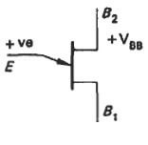

**3.POWER BJT:**

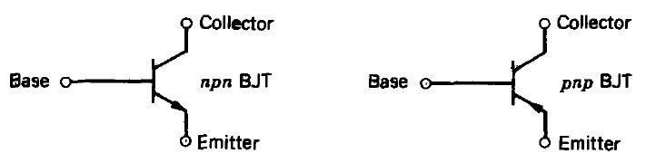

**4.SILICON CONTROLLED RECTIFIER:**

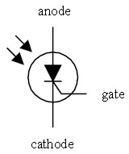

**5.REVERSE CONDUCTING THYRISTOR:**

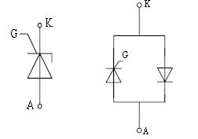

|  |  |
| --- | --- |
| **Experiment No. 7 a)**    **Date :** 04.11.2020 | **CHARACTERISTICS OF PN JUNCTION DIODE** |

**Aim**

To study the characteristics of PN Junction diode under forward and reverse bias conditions.

**Apparatus Required** **Components Required**

|  |  |  |  |  |  |  |  |  |
| --- | --- | --- | --- | --- | --- | --- | --- | --- |
| **S.No.** | **Name** | **Range** | **Qty** |  | **S.No.** | **Name** | **Range** | **Qty** |
| 1 | R.P.S | (0-30)V | 1 | 1 | Diode | IN4001 | 1 |
| 2 | Ammeter | (0–30)mA | 1 | 2 | Resistor | 1k | 1 |
| (0-500)µA | 1 | 3 | Bread  Board | - | 1 |
| 3 | Voltmeter | (0–1)V | 1 | 4 | connecting  Wires | - | Req |
| (0-10)V | 1 |

# Theory

A PN junction diode is a two terminal semiconducting device. It conducts only in one direction (only on forward biasing).

# Forward Bias

On forward biasing, initially no current flows due to barrier potential. As the applied potential exceeds the barrier potential the charge carriers gain sufficient energy to cross the potential barrier and hence enter the other region. The holes, which are majority carriers in the P-region, become minority carriers on entering the N-regions, and electrons which are the majority carriers in the N-region, become minority carriers on entering the P-region. This injection of minority carriers results in the current flow, opposite to the direction of electron movement.

# Reverse Bias

On reverse biasing, the majority charge carriers are attracted towards the terminals due to the applied potential resulting in the widening of the depletion region. Since the charge carriers are pushed towards the terminals no current flows in the device due to majority charge carriers. There will be some current in the device due to the thermally generated minority carriers. The generation of such carriers is independent of the applied potential and hence the current is constant for all increasing reverse potential. This current is referred to as Reverse Saturation Current (IO) and it increases with temperature. When the applied reverse voltage is increased beyond the certain limit, it results in breakdown.

During breakdown, the diode current increases tremendously.

# Procedure Forward Bias

1. Connect the circuit as per the diagram.
2. Vary the applied voltage V in steps of 0.1V.
3. Note down the corresponding Ammeter readings I.
4. Plot a graph between V & I

# Observations

1. Find the d.c (static) resistance = V/I.

2. Find the a.c (dynamic) resistance r = V / I (**r =** **V/****I) = (V2-V1)/(I2-I1)**

3. Find the forward voltage drop [Hint: it is equal to 0.7 for Si and 0.3 for Ge]

# Reverse Bias

1. Connect the circuit as per the diagram.
2. Vary the applied voltage V in steps of 1.0V.
3. Note down the corresponding Ammeter readings I.
4. Plot a graph between V & I
5. Find the dynamic resistance **r =** **V /** **I.**

**Formula for Reverse Saturation Current (IO):**

# *I* = *I*0(*e^(V* /*VT* )-1)

where *I* is forward (or reverse) diode current*, I0* is reverse saturation current*, V* is external voltage(+ve for forward bias & -ve for reverser bias),  is constant number (1 for Silicon and 2 for Germanium), *VT* is the volt-equivalent of temperature ( T/11600 ) and T is temperature in Kelvin. **Circuit Diagram**

**F**orward Bias

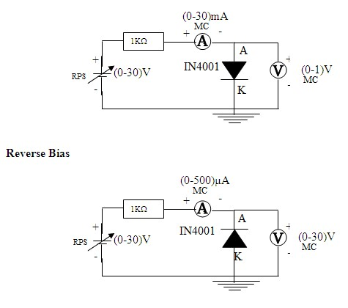

## Specification for 1N4001: Silicon Diode

Peak Inverse Voltage: 50V

Idc = 1A.

Maximum forward voltage drop at 1 Amp is 1.1 volts

Maximum reverse current at 50 volts is 5A

**Forward Bias:**

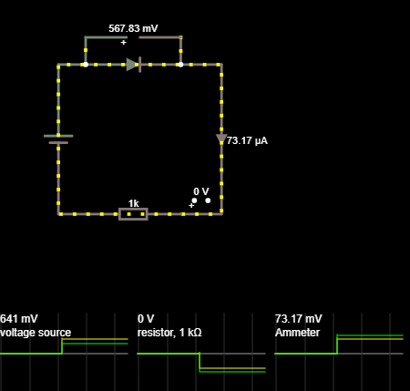

**Reverse Bias:**

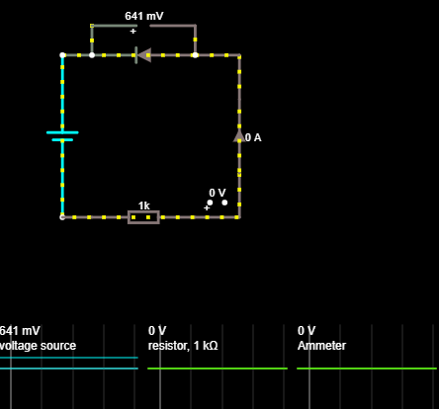

**Tabular Column**

## Forward Bias Reverse Bias

|  |  |  |  |  |  |  |  |  |  |  |  |  |  |  |  |  |  |  |  |  |  |  |  |  |  |  |  |  |  |  |  |  |  |  |  |  |  |  |  |  |  |  |  |  |  |  |  |  |  |
| --- | --- | --- | --- | --- | --- | --- | --- | --- | --- | --- | --- | --- | --- | --- | --- | --- | --- | --- | --- | --- | --- | --- | --- | --- | --- | --- | --- | --- | --- | --- | --- | --- | --- | --- | --- | --- | --- | --- | --- | --- | --- | --- | --- | --- | --- | --- | --- | --- | --- |
| |  |  |  | | --- | --- | --- | | **S.No.** | **Voltage Vf (In Volts)** | **Current If (In mA)** | | 1. | 0.641 | 1.36 | | 2. | 0.670 | 4.33 | | 3. | 0.689 | 9.31 | | 4. | 0.700 | 14.30 | | 5. | 0.705 | 19.29 | | 6. | 0.713 | 24.29 | | 7. | 0.718 | 29.28 | | |  |  |  | | --- | --- | --- | | **S.No.** | **Voltage Vr (In Volts)** | **Current Ir (In μA)** | | 1. | 2 | 0 | | 2. | 5 | 0 | | 3. | 10 | 0 | | 4. | 15 | 0 | | 5. | 20 | 0 | | 6. | 25 | 0 | | 7. | 30 | 0 | |

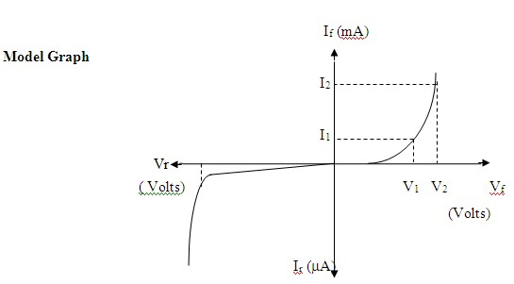

**Diode Graph:**

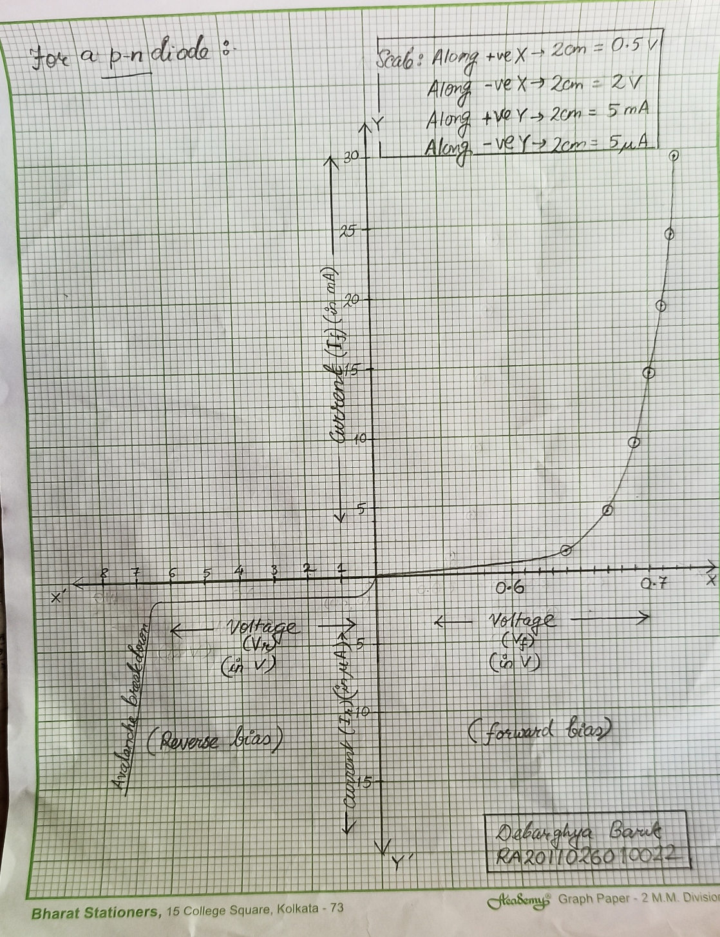

**Result :** From the experiment its concluded that under reverse biasing of diode the resistance is infinite and thus no current flows through it but when large voltage is applied the current overcomes the potential barrier and the value becomes infinite. In case of a forward biased diode it is noticed that current passes through it and there is an exponential increase in current as voltage is increased.

|  |  |
| --- | --- |
| **Experiment No. 7 b) Date :** 04.11.2020 | **CHARACTERISTICS OF ZENER DIODE** |

**Aim**

To find the forward and reverse bias characteristics of a given Zener diode.

## Apparatus Required Components Required

|  |  |  |  |  |  |  |  |  |
| --- | --- | --- | --- | --- | --- | --- | --- | --- |
| **S.No.** | **Name** | **Range** | **Qty** |  | **S.No.** | **Name** | **Range** | **Qty** |
| 1 | R.P.S | (0-30)V | 1s | 1 | Zener diode | FZ5.1 | 1 |
| 2 | Ammeter | (0–30)mA | 2 | 2 | Resistor | 1KΩ | 1 |
| 3 | Bread  Board | - | 1 |
| 3 | Voltmeter | (0–10)V | 1 | 4 | Wires | - | Req |
| (0–1)V | 1 |

## Theory

A properly doped crystal diode, which has a sharp breakdown voltage, is known as Zener diode.

## Forward Bias

On forward biasing, initially no current flows due to barrier potential. As the applied potential increases, it exceeds the barrier potential at one value and the charge carriers gain sufficient energy to cross the potential barrier and enter the other region. The holes, which are majority carriers in p-region, become minority carriers on entering the Nregions and electrons, which are the majority carriers in the N-regions become minority carriers on entering the P-region. This injection of minority carriers results current, opposite to the direction of electron movement.

## Reverse Bias

When the reverse bias is applied, due to majority carriers small amount of current (i.e.,) reverse saturation current flows across the junction. As the reverse bias is increased to breakdown voltage, sudden rise in current takes place due to Zener effect.

## Zener Effect

Normally, PN junction of Zener Diode is heavily doped. Due to heavy doping the depletion layer will be narrow. When the reverse bias is increased the potential across the depletion layer is more. This exerts a force on the electrons in the outermost shell. Because of this force the electrons are pulled away from the parent nuclei and become free electrons. This ionization, which occurs due to electrostatic force of attraction, is known as **Zener effect**. It results in large number of free carriers, which in turn increases the reverse saturation current.

## Procedure Forward Bias

1. Connect the circuit as per the circuit diagram.
2. Vary the power supply in such a way that the readings are taken in steps of 0.1V in the voltmeter till the needle of power supply shows 30V.
3. Note down the corresponding ammeter readings.
4. Plot the graph between V & I.
5. Find the dynamic resistance **r =** **V /** **I.**

## Reverse Bias

1. Connect the circuit as per the diagram.
2. Vary the power supply in such a way that the readings are taken in steps of 0.1V in the voltmeter till the needle of power supply shows 30V.
3. Note down the corresponding Ammeter readings I.
4. Plot a graph between V & I
5. Find the dynamic resistance **r = δV / δI.**
6. Find the reverse voltage Vr at Iz = 20mA

## Circuit Diagram

## Forward Bias

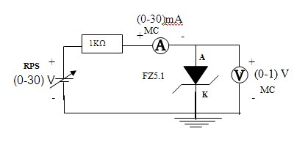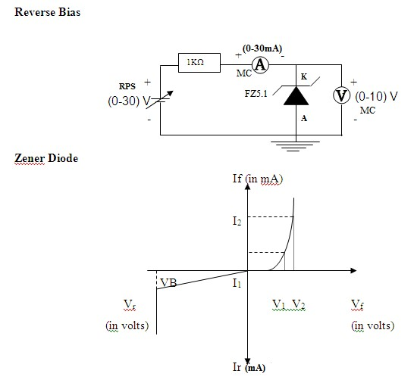

**Forward Bias:**

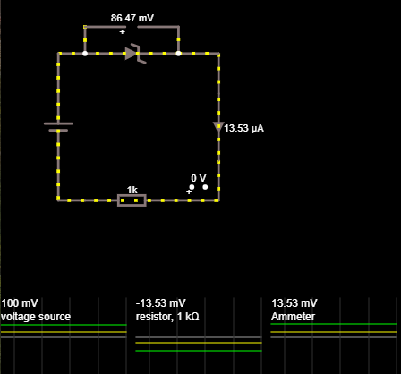

**Reverse Bias:**

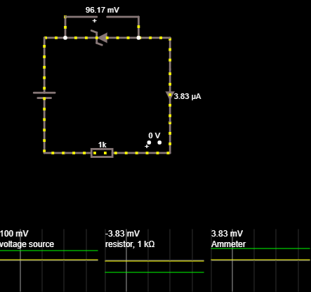

## Tabular Column

## Forward Bias Reverse Bias

|  |  |  |  |  |  |  |
| --- | --- | --- | --- | --- | --- | --- |
| **S.No.** | **Voltage (In Volts)** | **Current (In uA)** |  | **S.No.** | **Voltage (In Volts)** | **Current (In uA)** |
| 1 | 0.1 | 13.5 | 1 | 0.1 | 3.8 |  |
| 2 | 0.2 | 46.3 | 2 | 0.2 | 4.7 |  |
| 3 | 0.3 | 99.4 | 3 | 0.3 | 4.9 |  |
| 4 | 0.4 | 166.6 | 4 | 0.4 | 5 |  |
| 5 | 0.5 | 242.4 | 5 | 0.5 | 5 |  |
| 6 | 0.6 | 323.6 | 6 | 0.6 | 5 |  |
| 7 | 0.7 | 408.5 | 7 | 0.7 | 5 |  |
| 8 | 0.8 | 495.8 | 8 | 0.8 | 5 |  |
| 9 | 0.9 | 585.0 | 9 | 0.9 | 5 |  |
| 10 | 1.0 | 675.6 | 10 | 1.0 | 5 |  |

## THEORETICAL VALUES

## FORWARD BIAS(ZENER)

* Dynamic resistance=∆V/∆I = 1.01ohm

**REVERSE BIAS (ZENER)**

* AC resistance=∆V/∆I = 1.02 ohm
* Voltage Vrat Iz = 20 mA for 0.0013V

Io=Is[eaVd/NkT - 1 ]

S/R= 20[e-1.6*10^-14*Vd/2*295*K - 1]

1.025=e-19.65Vd

Vd= -1.257*10-3V

**Zener Diode Graph:**

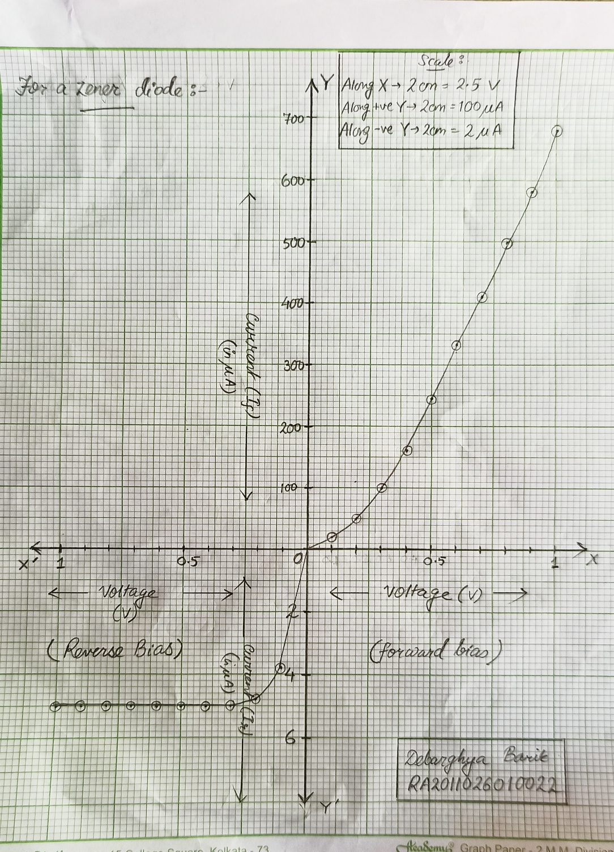

## Result : In case of forward biased Zener diode it is observed that there is gradual in increase in current as voltage is increased .In case of reverse biased Zener diode at starting there is increment in value of current but after some tie the value of current remains unchanged for a long period of values then when the value of voltage is further increased then it is observed that there is an exponential rise in current too.

--------------------------------------------x------------------------------------------